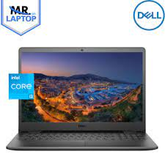

Dell Inspiron I3

* 11th Generation Core I3
* 6MB Cache,To 4.1 GHz
* Ram 4GB DDR4
* Graphic Card
* **Rs.82,000**